library(readr)

library(ggplot2)

**Data Read**

data1 <- read_csv("car_sales.csv")

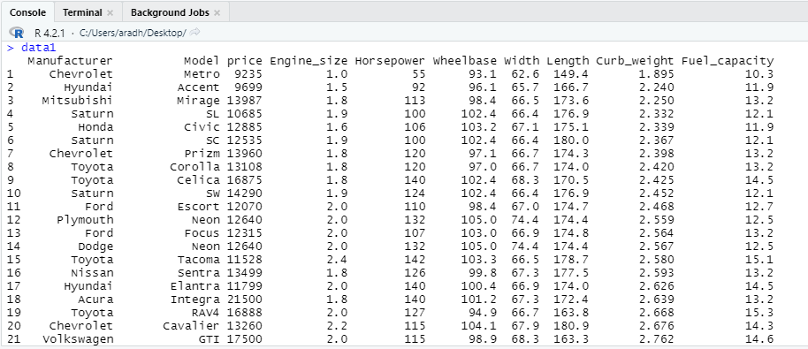

**Summary**

summary(data1)

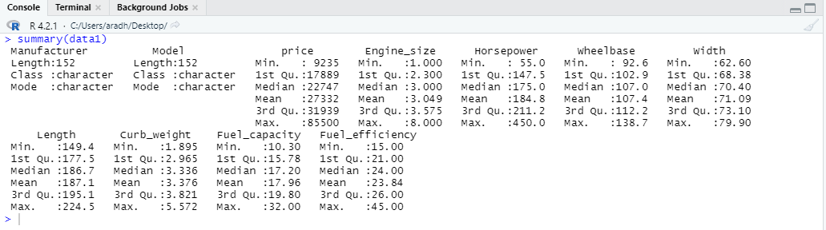

**Selecting Price Column**

data2 <- data1[c('price')]

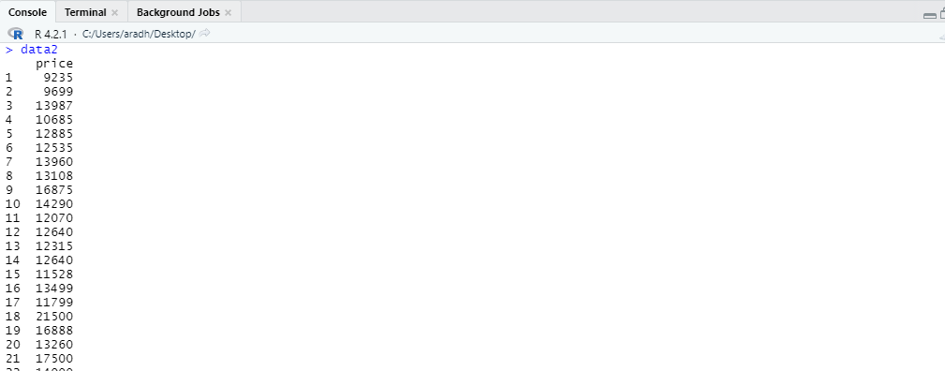

**Finding Mean, Median, Variance, SD, Min, Max and Range**

str(data2) 

mean(data2$price)

median(data2$price)

var(data2$price)

sd(data2$price)

min(data2$price)

max(data2$price)

range(data2$price)

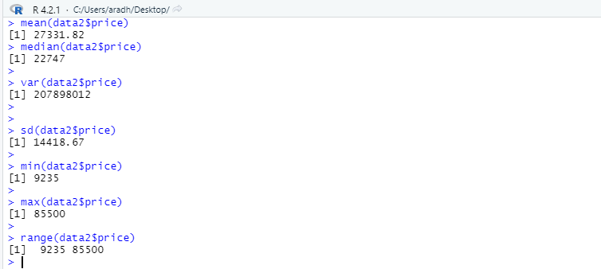

**Trimmed Mean**

mean(data2$price, trim=0.1)



**25th and 75th Percentile**

quantile(data2$price, probs = c(.25, .75))



**Interquartile Range**

IQR(data2$price)

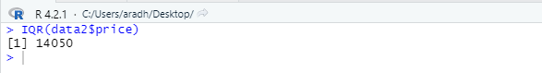

Lower and Upper Fence

data3 <- quantile(data2$price, probs = c(.25))

data4 <- quantile(data2$price, probs = c(.75))

data5 <- IQR(data2$price)

lfence <- data3 - (1.5*data5)

ufence <- data4 + (1.5*data5)

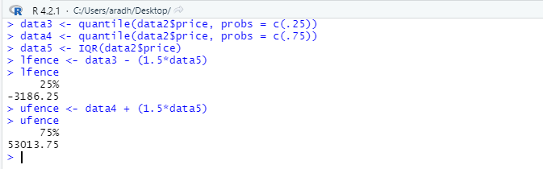

**Outliers**

data2[data2$price >= 53013.75, ]

data2[data2$price <= -3186.25, ]

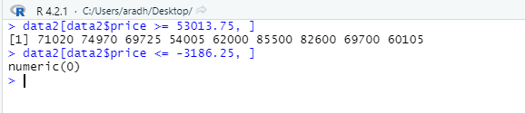

Coefficient of Variation

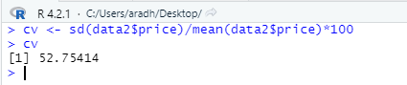

data3 <- as.numeric(data2$price)

> hist(data3)

data2 <- data1[c('price')]